DESIGN AND IMPLEMENTATION OF AN AUTOMATED VEHICLE THEFT REPORTING SYSTEM
(A CASE STUDY OF NIGERIAN POLICE FORCE, BAJOGA DIVISION)

BY GROUP SIX (6)
S/N | NAME | REG. NO
1 | MUBARAK MUHAMMAD | ND/CS/21/1046
2 | EZIKIEL M. SANI | ND/CS/21/1011
3. | ABDULLAHI YAKUBU UMAR | ND/CS/21/1962

A PROJECT SUBMITTED TO THE DEPARTMENT OF COMPUTER SCIENCE, SCHOOL OF SCIENCE AND TECHNOLOGY, GOMBE STATE POLYTECHNIC BAJOGA IN PARTIAL FULFILLMENT OF THE REQUIREMENT FOR THE AWARD OF NATIONAL DIPLOMA (ND) IN
COMPUTER SCIENCE

FEBRUARY, 2024.

DECLARATION
We hereby declared that this work is the invention of our research effort, under taken under the supervision of Malam Haruna Ahmad Dokoro and has not been presented and will not be presented elsewhere for the award of ND certificate. All sources have been dully acknowledged.

S/N | NAME | SIGNATURE | DATE
1 | MUBARAK MUHAMMAD
2 | EZIKIEL M. SANI
3. | ABDULLAHI YAKUBU UMAR

CERTIFICATION
This is to certify that the project titled “Design and Implementation of automated vehicle theft reporting system” was carried out under the supervision of:

Malam Haruna Ahmad Dokoro ___________________
(Project Supervisor) Date

Mr. Isma’il Abdulkarim Adamu ____________________
(Head of Department) Date

______________________________ _____________________
Name and Signature Date
(External Examiner)

ACKNOWLEDGMENT
We gave the glory to Allah for everything he has done in my life throughout the duration of my studies, we want to sincerely appreciate the effort of our supervisor Malam Haruna Ahmad Dokoro for giving us the genuine advice during this project, encouragement, moral and intellectual support because without him this project would not have been successfully completed. We pray that Allah almighty will prosper you in your entire endeavor

DEDICATION
This project is dedicated to almighty God and other people that supported us from all angles.

Table of Contents
DECLARATION ii
CERTIFICATION iii
ACKNOWLEDGMENT iv
DEDICATION v
ABSTRACT x
LIST OF FIGURES ix
CHAPTER ONE 1
1.0 INTRODUCTION 1
1.2 BACKGROUND OF THE STUDY 2
1.3 STATEMENT OF THE PROBLEM 3
1.4 JUSTIFICATION OF THE STUDY 3
1.5 AIM AND OBJECTIVES OF THE STUDY 4
1.6 SCOPE OF THE STUDY 4
1.7 LIMITATION 4
1.7 RESOURCES AND TECHNOLOGIES USED 4
1.7.1 HARDWARE 4
1.7.2 SOFTWARE 5
1.7.3 TECHNOLOGIES/LANGUAGES 5
1.8 DEFINITION OF KEY TERMS 5
1.8 CHAPTERIZATION 6
CHAPTER TWO 7
2.1 THEORETICAL BACKGROUND 7
2.1.1 CRIME CONTROL 8
2.1.2 ROLE OF THE POLICE IN VEHICLE THEFT CONTROL 10
2.1.3 VEHICLE THEFT REPORTING PATTERNS AND POLICING STRATEGIES 11
2.1.4 CONCEPT OF CRIME REPORTING 14
2.1.5 STATISTICS OF CRIMES IN NIGERIA 15
2.2 REVIEW OF RELATED LITERATURES (EXISTING SYSTEMS) 16
2.2.1 DEFINITIONS OF MOTOR VEHICLE THEFT 17
2.2.2 APPROACHES TO REDUCE THE OCCURRENCE OF MOTOR VEHICLE THEFT 19
CHAPTER THREE 25
METHODOLOGY 25
3.1 INRODUCTION 25
3.2 PRELIMINARY INVESTIGATION 25
3.3 FEASIBILITY STUDY 26
3.4 OVERVIEW OF THE EXISTING SYSTEM 26
3.5 ANALYSIS OF THE EXISTING SYSTEM 27
3.6 OVERVIEW OF THE PROPOSED SYSTEM 27
3.7 ANALYSIS OF THE PROPOSED SYSTEM 27
3.8 SYSTEM DESIGN 27
3.8.1 USE CASE DIAGRAM 28
3.8.2 SEQUENCE DIAGRAM 29
3.8.3 LOGICAL DESIGN 30
3.8.4 PHYSICAL DESIGN 30
3.8.5 DATABASE DESIGN 34
Table 1: Admin Table [admin] 34
Table 2: Security Defense [dept] 34
Table 3: Lodged Reports [lodge] 34
Table4: Rescued Vehicles [rescued] 35
CHAPTER FOUR 36
SYSTEM IMPLEMENTATION TESTING 36
4.1 INTRODUCTION 36
4.1 SYSTEM IMPLEMENTATION 36
4.2 SYSTEM TESTING 36
4.2.1 ADMINISTRATOR DASHBOAR 39
CHAPTER FIVE 44
SUMMARY, CONCLUSION AND RECOMMENDATION 44
5.1 SUMMARY 44
5.2 CONCLUSION 44
5.3. RECOMMENDATION 45
REFERENCE 46

LIST OF FIGURES
Figure 3.0: Use case diagram 28
Figure 3.1: Sequence diagram 29
Figure 3.2: Level 0 Dataflow Diagram 30
Figure 3.3: Admin Flowchart 31
Figure 3.4: Security Defense Flowchart 32
Figure 3.5: Security Defense Flowchart 33
Figure 4.1: Black box testing 37
Figure 5.2: Admin dashboard 40
Figure 5.4: Theft report 41
Figure 5.6: security defence dashboard 42
Figure 5.7: View Theft report 42
Figure 5.9: User page 43

ABSTRACT
The rise in vehicle theft crime wave in Nigerian urban centres in the wake of the 2015 general elections and 2016 economic recession, undoubtedly accentuated the need for improved security. This study developed an automated system that will enable users to lodge theft reports automatically to let security defence take all the necessary action. However, this study used primary data collected from public and police samples drawn from three purposively Bajoga Division, Funakaye Local Government Area Gombe State.

CHAPTER ONE

1.0 INTRODUCTION
Vehicle theft is one of the most criminal act in Nigeria especially Gombe State. People are losing their vehicles because of theft and as a result the security defence are trying their best to rescue those vehicles but few of them are recovered. The reason beyond that is, most of the people are not able to report the theft at the appropriate time of the incidence due to lack of access to the security defence which result into the loss of the vehicle. This research will provide a medium whereby people can lodge their complain of vehicle theft online at the proper time of the incidence to enable the security defence take all the necessary action to rescue the stole vehicle. The research is aimed to provide a medium whereby report of theft will be lodged online to enable the security defence received reports and to reduce the loss of vehicles in our society.
Incidences of vehicle theft are reported to the Nigeria Police Force for investigation that would lead to the recovery of such vehicles, apprehension and prosecution of the offenders. Some of the stolen vehicles end up not being recovered and the perpetrators end up escaping the long arms of the law. This tends to encourage the continued indulgence in the unwholesome activity and attracting other criminally-minded persons to engage in it.
Criminologist Frank E. Hagan wrote that, "Probably the most important factor in the rate of motor vehicle theft is the number of motor vehicles per capita in the country." Using data supplied by the United Nations Office on Drugs and Crime, the estimated worldwide auto-theft rate is 85.3 per 100,000 residents. However, data is not available for all countries, and this crime rate reflects only the most recent year (2018) of reported data.
Poor recovery of stolen vehicles in Nigeria has cost vehicle owners to lose about N1.8 billion between 2013 and 2015, the analysis of data on stolen and recovered vehicles has shown.
Data from the National Bureau of Statistics (NBS), shows that 2, 544 vehicles were stolen between 2013 and 2015, out of which 1,377 vehicles were recovered, and this brings the national recovery rate to 54 percent.
This means that the Nigerian institutions involved in the recovery of stolen vehicles have the ability to recover only 5 out of every 10 vehicles stolen in the country. And at an average price of N1.5 million per vehicle, the 1,167 stolen but not recovered vehicles amounted to N1.8 billion in loss to their owners.
Further analysis of the NBS data shows that while the nation’s stolen vehicle recovery capability is 5 out of 10 stolen vehicles, only 14 states were able to achieve better results than the national average. Gombe State topped the list while Kebbi State is at the bottom of the list. No data is available on Katsina and Kogi states.
During the period, 77 vehicles were stolen in Gombe State, out of which 61 have been recovered, meaning that the police command in that state has the capacity to recover 8 out of every 10 stolen vehicles. Edo and Kaduna states’ police commands have 76 percent and 75 percent recovery rates meaning that they too could recover 8 out of every 10 stolen vehicles in their states. Ogun and Plateau states police commands could also recover 7 out of every 10 vehicles stolen in their states.

1.2 BACKGROUND OF THE STUDY
Motor vehicle theft (also known as a car theft and, in Nigeria, grand theft auto) is the criminal act of stealing or attempting to steal a motor vehicle (Gaub J.E 2018). Nationwide in the Nigeria in 2020 (Hills A.E 2020), there were 810,400 vehicles reported stolen, up from 724,872 in 2019. Property losses due to motor vehicle theft in 2020 were estimated at $7.4 billion. There were 505,100 car thefts in the EU in 2019 (A.Sirajo & Zakariya 2022), a 43% decrease from 2008 ( Adegoke N. 2014).
The problem of vehicle theft is always arising, people are always crying due to lack of immediate access to security defence. Analysis shows that most vehicles are being lost due to delay of reporting the incidence that happened. Also, there is no any standard database of vehicles theft reporting which leads to loss of records of reported theft and finally the vehicle itself. Therefore, this research will provide a remedy tot the problems stated above through developing a system that will handle a lot of data in the database for further inquiries. It will also allow people to lodge their vehicle theft reports online.

1.3 STATEMENT OF THE PROBLEM
The main problem of the old system used at security defence is lack of centralized database for stolen vehicles which leads to difficulty in identifying stolen vehicle by vehicle registration officers, unable to lodge theft report at the stipulated time of the incidence which result in delay of the report before reaching the security defence, and to the end loss of the vehicle entirely.
Most people are getting bored when reporting their stolen vehicle at Nigerian Police Force station, because they are not well acquainted with the station and its activities. Moreover, manual method of reporting stolen vehicle is moderately difficult and undergoes an elongated procedure. Due its elongated technique, reporters can concurrently loss his vehicle before the necessary action is to be taken by the police force.

1.4 JUSTIFICATION OF THE STUDY
Today, auto thefts are climbing and have been doing so for the last couple of years. According to (Nigerian Police Crime Report Abuja, 2017) own data, auto thefts are up to a level not seen in more than a decade.
In recent times property theft has become a major concern. Out of this vehicle theft tops the list and occurs often in all parts of the world. In light of this issue many technologies are evolving and new methods are developed in order to resolve this issue. The methods involved in vehicle theft detection have become aware to everyone including the burglars and they try to break the system and steal the vehicle. This paper proposes a system presenting a mechanism reports of theft can be done online to minimize vehicle thefts.

1.5 AIM AND OBJECTIVES OF THE STUDY
AIM:
The aim of this project is to develop a web based vehicle theft reporting system.
OBJECTIVES:
i. To minimize the number of vehicle theft cases.
ii. To have a centralized database for stolen vehicles
iii. To simplify the Process of reporting vehicle theft cases
iv. To assist vehicle registration officers in identifying stolen vehicles.

1.6 SCOPE OF THE STUDY
This research can be done at Nigerian Police Force, Bajoga Division where the feasibility study of the research took place.

1.7 LIMITATION
The system is not able to contact a reporter directly upon vehicle recovery, when a vehicle is recovered; its record is posted in the website so that a visitor can have access to it.

1.7 RESOURCES AND TECHNOLOGIES USED
Where the resources (hardware and software) and the technologies used during the implementation of the system. Are presented here.

1.7.1 HARDWARE
Personal Computer (Laptop/desktops) is the hardware component used in developing this system using Windows Operating System.

1.7.2 SOFTWARE
Visual Studio Code (VS Code) and XAMP is used in performing all the functions performed in this system.

1.7.3 TECHNOLOGIES/LANGUAGES
HTML, CSS are the languages used in developing the front-end of the system, MySQL is the database used to store all the records for easy retrieval, whereas PHP is the language used to allow interaction between the server and the system while data validation of the system is achieved using JavaScript and AJAX.

1.8 DEFINITION OF KEY TERMS
VEHICLE: A vehicle is a machine designed for self-propulsion, usually to transport people or cargo, or both. Vehicles include wagons, bicycles, motor vehicles, railed vehicles, watercraft, amphibious vehicles, aircraft and spacecraft.
THEFT: Theft is the act of taking another person's property or services without that person's permission or consent with the intent to deprive the rightful owner of it.
REPORT: A report is a document or a statement that presents information in an organized format for a specific audience and purpose. Although summaries of reports may be delivered orally, complete reports are usually given in the form of written documents. Typically reports relay information that was found or observed.
REPORTING SYSTEM: A system that enables a company to measure, track, manage and communicate its performance and progresses for example in terms of social, environmental and economic impacts. Consumer Confidence in Responsible Tourism: How Business Reporting Systems can Encourage Respectful Behaviour.
HTML: Hypertext Markup Language ‘
CSS: Cascading Style Sheet
PHP: Hypertext Preprocessor
AJAX: Asynchronous JavaScript and XML is a set of web development techniques that uses various web technologies on the client-side to create asynchronous web applications.
VS Code: Visual Studio Code is a source-code editor made by Microsoft for Windows, Linux and macOS.

1.8 CHAPTERIZATION
Chapter One: Introduction
Chapter Two: Literature Review
Chapter Three: System Design/Methodology
Chapter Four: Implementation and Testing
Chapter Five: Summary, Conclusion and Recommendation

CHAPTER TWO

2.1 THEORETICAL BACKGROUND
Scholars and social analysts have defined vehicle theft from different perspectives. As such, a general definition of the concept has eluded the academia for years. While Farmer Lindsay see vehicle theft as a category created by law16s (Tayo J.A 2021), Elizabeth A. Martin provided a more comprehensive definition when she noted that vehicle theft or offence (or criminal offence) is an act harmful not only to some individual or individuals but also to a community, society or the state ("a public wrong") (Gauri Satya 2014)). It refers to actions that are forbidden by law; offence against the state, conducts such as committing murder, stealing property, resisting arrest, driving while under the influence of alcohol and possessing or selling illegal drugs and seen as an act that violates a political or moral rule; an act of a single individual acting from personal motive, or maybe organized activity whereby gangs of mobsters seek to enrich themselves at the expense of the general public, and resort to violence and murder in order to achieve their goals.
Vehicle theft is traceable to the formation of groups by individuals who have related interests with the aim of having a strong network.
Theoretically, most discourses on the causes of vehicle theft are usually hinged on greed/grievance, relative deprivation, frustration and aggression theory of social conflict as well as the theory of reasoned action which sees criminal act as a well planned action by the perpetrators. The trouble with vehicle theft is that it is usually associated with greed and violence which greatly motivate the violation of inalienable rights.
Vehicle theft and its impact have continued to plague societies. It has been argued that the eighteenth century heralded a breakthrough in vehicle theft theories and penalty, as from the mid-18th century several commentators published on issues to do with policing, the care of delinquent youths, the state of the prisons, and the nature of punishment (Shore, Baoteng F.G 2005). The history of policing has been traced to informal policing where every member of the community was involved in maintaining order (Reid, J.I 2015) The first modern public police force was created in 1829 following the passing of the London Metropolitan Police Act, under the leadership of Sir Robert Peel (Fagin, 2016).
The police vis-à-vis its role in controlling vehicle theft has always come under public scrutiny. Owen et al. 2015) have argued that the mere mention of the word “police” may provoke either positive or negative response. They also observed that the history of policing shows that policing strategies have changed overtime when viewed in the light of best police practices. Policing activities become more herculean with the growth of modern cities that serves as a melting pot of cultures and a congregation of people with diverse orientation and agenda. Urban centres all over the world, including Nigeria, perhaps put to test the vehicle theft control capabilities of the modern public police service. The eleventh goal of the Sustainable Development Goal (SDG) is to “make cities inclusive, safe, resilient and sustainable” (Ayodele J.O 2017). The police therefore have a pivotal role in ensuring safe environment.
Given that the art of policing is dynamic, there is the need to periodically investigate how effectively the public police service is performing its statutory functions of vehicle theft control and order maintenance. There is also the need to examine public attitudes towards the police. (Schapp, 2020) underscores the role of public trust in effective policing. (He et al. 2018) argue that public opinion plays an important role in influencing government policies and keeping government officials in check.

2.1.1 CRIME CONTROL
Controlling the crime is a significant social issue and one of the chief undertakings of any government. Obviously, for this to happen, crime needs to go to the attention of the government. In this regard, the victim’s decision to report any criminal activity is essential. Victim reports are the key source of information for the police and are the basis for most subsequent actions of the justice system. Though, a lot of crimes are not reported to the police. Recent findings show, for instance, that only half of all incidents of six types of crimes in 17 industrialized countries are reported to the police (Bouten, Goudriaan, & Nieuwbeerta, 2002). In regard to understanding why victims report (or fail to report) is important for the development and implementation of crime control strategies, and specifically for efforts to increase the percentage of crimes that are reported to the police. The costs of crime are tangible and intangible, economic or social, direct or indirect, physical or psychological, individual or community. In fact, it is from the cost that the consequences of crime are derived. The price of crime can be incurred as a result of actual experience of criminal activities when there is physical harm when belongings are stolen, damaged or destroyed. It could also be in the form of mental and emotional pains as a result of shock due to the crime done against the victim. Besides, the cost of crime can be incurred in an attempt to report, prevent or control crime. As a consequence of the predominance of crime in society, the demographic makeup may be altered through the mass movement of people from crime prone areas to areas perceived to be relatively crime-free. This can else lead to brain-drain and other socio-economic problems. Crime is a threat to the economic, political and social security of a nation and a major factor associated with underdevelopment; reason it discourages both local and foreign investments, reduces the quality of life, destroys human and social capital, damaged relationship between citizens and the states, thus undermining democracy, rule of law and the ability of the nation to promote development. The prime tasks of the police are to uncover committed crime and to prevent future crime. To succeed in this, the cooperation of victims is indispensable. The police urge citizens to report crimes because it is necessary in order to maintain police statistics up-to-date and to keep the criminal justice system functioning. Unfortunately, not all victims report crime to the police (Jochem, 2011). In this respect, a victim’s decision to report crime to the police is crucial.

2.1.2 ROLE OF THE POLICE IN VEHICLE THEFT CONTROL
Policing, order maintenance and control of lawbreakers has historically been carried out by private citizens (Dempsey & Forst, Citation2008). However, the first modern public police force was established in 1829 by England Home Secretary, Sir Robert Peel (Siegel, Citation2009). The police are one of the most strategic government institutions of social control (Lambert et al., Citation2010). The police service is empowered by the state to ensure the safety and security of its citizens when either individually or collectively citizens behave disorderly or unlawfully (Brown, Citation1998). The role of the police in society conditioned by three fundamental concepts: order maintenance, the right to legitimate use of force and the exercise of discretion (Owen et al., Citation2015).
There is a body of research that attempts to assess the role of police in controlling vehicle theft in NigeriaCitation2019 and how the public perceive this role. Soyombo (Citation2004) noted that the police were established to serve the public and therefore should tailor their activities to fit into public interest. He further pointed out that it is through empirical research that the police will be able to know the needs, expectations, concerns and perceptions of the public. Alemika (Citation1988) worried about the dearth of research on the historical, socio-political, and economic foundations and characteristics policing in Nigeria interrogated the dynamics of policing in Nigeria and provided a tentative scale for measuring public perception of Nigerian police. Similarly, Ajayi and Longe (Citation2015) examined public perception of the police and vehicle theft prevention in Nigeria and found that the police insensitivity to the public has inhibited a harmonious relationship between them and the public. Chinwokwu (Citation2013) investigated the role of the police in vehicle theft and criminal investigation in Enugu State Police Command. His findings identified lack of training, skills, facilities, corruption, disobedience to due process, and ethical standards as part of the factors responsible for undetected and pending cases in Nigeria and Enugu State.
Furthermore, Hills (Citation2011) examined the role of the Nigeria Police in Metropolitan Kano. She found that Kano experience demonstrates how locally oriented forms of policing can be very useful in reducing tension. Karimu (Citation2014) assessed the performance of the Nigeria police in vehicle theft prevention and control in Osun State, Nigeria. He found that Nigeria’s socio-political order impedes the effective performance of the police, coupled with high level of unemployment in the country, which makes vehicle theft control more challenging for the police. Adegoke (Citation2014) examines the Nigeria police and the challenges of security. The study identified poverty, unemployment, leadership and religion as the root causes of insecurity in Nigeria and observed that the Nigeria police alone cannot combat insecurity in the country. Akinlabi (Citation2017) examined the problem of corrupt policing and other related abuses in Nigeria and how such deviant behaviours can encourage public cynicism towards the law. He found that the public are very cynical about the law and have high perceptions of police corruption and police abuse. These studies are perhaps provoked by the need to reform the police in Nigeria to reposition them to be more able to fulfil their statutory functions. One of such functions is vehicle theft prevention and control. However, most of the empirical studies that have investigated police role in vehicle theft prevention and control, including those reviewed in the current study, have utilized data from the public samples alone. The present study therefore differs in the sense that it collected data from both the public and police samples. This enabled the study to generate data that offer a broader view of the subject matter.

2.1.3 VEHICLE THEFT REPORTING PATTERNS AND POLICING STRATEGIES
The reporting of vehicle theft to the police by the public can be driven by a number of factors. According to Benneth and Lynch (as cited in Kochel et al., Citation2013), such factors may include: (a) a sense of civic duty, (b) practical consideration such as a case that has to do with auto theft where reporting is a pre-requisite for an insurance claim or, (c) fear and effort to forestall future victimization. A study by that borrowed from a Taiwan victimization survey investigated victim reporting of assault, robbery, and larceny. The study found that the severity of infraction was positively related to vehicle theft reporting. Another study by Ozascilar et al, (Citation2019) which interrogated the willingness of Syrian immigrants to report vehicle theft found that Syrians are favourably disposed to reporting vehicle theft to the police and that satisfaction with the police as well as household size had a positive correlation with vehicle theft reporting practices. Xie (Citation2014) compared area differences and time trends in vehicle theft reporting in New York with other metropolitan areas and found that the New York metropolitan area had lesser vehicle theft reporting rate than other metropolitan areas. Watkins and Maume (Citation2011) used data from the School Vehicle theft Supplement to the National Vehicle theft Victimization Survey to investigate whether school-related factors, such as the presence of security operatives, influence students’ reporting of school violent vehicle theft s to police or non-police authorities. The study found little differences in reporting from 1999 to 2007 and little evidence to demonstrate that school-related factors influence the decision to report. Ayodele (Citation2015) examined vehicle theft reporting practices among market women in Oyo, Nigeria and found that because market women have low confidence in the police’s ability and willingness to arrest criminals, they are reluctant to report vehicle theft to the police. A recent study by Weijer et al. (Citation2018) used data from four wave of a Dutch cross-sectional population survey to examine the determinants of reporting cybervehicle theft . It found that cybervehicle theft s are part of the least reported variants of vehicle theft . It is quite understandable that cybervehicle theft s constitute part of the least reported vehicle theft . By their nature, cybervehicle theft s are complex and evolving. Therefore, many victims may not know about their victimization till after a long period of time. Besides, some victims even when they know, for example, that their social media accounts have been compromised, they may not deem it necessary to report to the police after they have secured it.
The Police have employed several strategies to control vehicle theft and criminality over the years. Willis (Citation2014) identified some of these strategies to include: problem-oriented policing, order maintenance policing, community policing, zero tolerance policing, and policing vulnerable populations. Obviously, each of these five policing strategies is unique and therefore requires a tailor-made approach during its execution. But, the aforementioned five strategies are not the only policing strategies that are deployed by police authorities to control vehicle theft . Hot spots policing have proven to be effective in reducing vehicle theft (see Braga et al., Citation2014; Telep et al., Citation2014). The police in t Kano Petropolis use patrol as one their vehicle theft control strategies. A study on the nature of patrol in the area revealed that majority of the respondents considered it beneficial to the police as a preventive vehicle theft control strategy (Radda et al., Citation2011). This is understandable as through routine patrol; especially of hot spots the police can effectively prevent vehicle theft from occurring in the first place. But, beyond that, the police can intervene in active vehicle theft scenes, apprehend suspects, and collect physical evidence from the scene.
The police use geographic profiling to map connected criminal acts to identify the location of the suspect’s residence (see, Worrall & Schmalleger, Citation2016). In the digital age, the police increasingly use social media in its communications (see, Fielding, Citation2021; Hu et al., (Citation2018). Furthermore, the use of body-worn cameras (BWCs) is becoming popular in the United States and other countries (Gaub et al., Citation2018). Third-party policing strategy can be useful in controlling cybervehicle theft in Nigeria (Ndubueze & Igbo, Citation2014). Regensburger (Citation2012) opined that the goal of law enforcement is to collect admissible evidence and that they hire investigative personnel in order to solve major vehicle theft s. He further explained that specialized vehicle theft scene investigators (CSIs) are basically required to process vehicle theft scene and often used by law enforcement agencies to document vehicle theft scene and collect physical evidence.
Importantly, the police largely rely on the cooperation of the public to detect and control vehicle theft . This therefore implies that the wider the gap between the police and the community, the more difficult it is for the police to effectively control vehicle theft in the community.
There have been several efforts towards reforming the police to make it deliver better service (Willis, Citation2014). Community justice which is a novel set of policing ideas advocates’ custom-fit vehicle theft control rather than the traditional approach (Worrall & Schmalleger, Citation2016). Perkins (Citation2016) investigated how perceptions of the police differ between neighbourhoods in York, United Kingdom and found that the factors that influence the views of individuals may differ according to how individuals see their local areas. The study further suggests that policing reforms that are meant to improve public confidence in the police must align with the views of residents about their communities. A study by E. C. Chinwokwu (Citation2017) that examined
the way police personnel are managed for effective vehicle theft control in Nigeria underscores the need for effective police reform programme that will ensure that the police and the community they serve work in harmony.

2.1.4 CONCEPT OF CRIME REPORTING
Reporting crime to the police is defined as notifying the Police of a crime that took place. In most cases, crime reporting takes place at a Police Station. However, it is also possible to notify the Police by telephone and nowadays one can report minor crimes via the Internet in many (Western) countries. Of course, sometimes the police are already on the scene when a crime takes place (Anderson, 1999). In everyday language people talk about reporting to the police regardless of whether an official report has been made by the Police and signed by the person who reported (in most cases the victim or a witness), or whether the Police have only been informed and no report has been signed. However, if no report has been signed, formally no melding (notification) has to take place. It is not about what the Police do after they have been notified (e.g. whether they register the crime or not, or whether they take any action after the notification), but about whether they have been informed of the crime. Thus, the focus is on whether victims contact the Police or not (Wittebrood, 2004).

2.1.5 STATISTICS OF CRIMES IN NIGERIA
Nigeria has one of the highest crime rates in the world. Murder often accompanies minor burglaries. Rich Nigerians live in high security compounds. Police in some states are empowered to “shoot on sight” violent criminals (Financial Times, 2009). In the 1980s, serious crime grew to nearly epidemic proportions, particularly in Lagos and other urbanized areas characterized by rapid growth and change, by stark economic inequality and deprivation, by social disorganization, and by inadequate government service and law enforcement capabilities (Nigeria, 1991). Annual crime rates fluctuated at around 200 per 100,000 populations until the early 1960s and then steadily increased to more than 300 per 100,000 by the mid-1970s. Available data from the 1980s indicated a continuing increase. Total reported crime rose from almost 211,000 in 1981 to between 330,000 and 355,000 during 1984 – 85. The British High Commission in Lagos cited more than 3000 cases of forgeries annually (Nigeria, 1991). In the early 1990s, there was growing number of robberies from 1,937 in 1990 to 2,419 in 1996, and later the figure declined to 2,291 in 1999. Throughout the 1990s, assault and theft constituted the larger category of the crime. Generally, the crime data grow from 244,354 in 1991 to 289,156 in 1993 (Cleen, 1993) and continued to decline from 241,091 in 1994 to 167,492 in 1999 (Cleen, 2003). The number of crime slightly declined to 162,039 in 2006, a reduction of 8 percent from 2005 (Cleen, 2006). Most alarming and terrifying is the present escalation of violent crimes and the barbarity, lethality and trauma the perpetrators unleash on the hapless citizenry across the country. Notable in this regard are the rising incidents of armed robbery, assassination and ransomdriven kidnapping which are now ravaging the polity. So far, the prevalent increasing waves of violent crimes in Nigeria have questioned the political will on the part of the leaders and the capability of the law enforcement agencies in containing the challenges. In the past, armed robbers used to operate only in the night. But today, they operate both night and day, attacking homes, offices, banks, shops, restaurants and churches to rob rape, maim and kill. They attack banks with dynamites, strike at filling stations and swoop on victims at traffic jams (Emeh, 2012; Ugwuoke, 2010; Igbo, 2007). Similarly, rape, sea piracy, cultism has taken sharp and increasing dimension in recent times.

2.2 REVIEW OF RELATED LITERATURES (EXISTING SYSTEMS)
Concepts like vehicle theft control, vehicle theft reporting, vehicle theft prevention, vehicle theft combatting and vehicle theft deterrence are commonly used in discourses on the efforts of the criminal justice system to maintain law and order in society. Vehicle theft prevention basically refers to any proactive measure designed to block or reduce the chances of vehicle theft occurring at particular place or the onset of criminal behaviour in a person (Schneider, 2015). Vehicle theft control deals with the efforts to fight vehicle theft in society. It is synonymous with the term “vehicle theft combatting”. Vehicle theft control (public order) model essentially focus on fighting vehicle theft and protecting potential victims (Fagin, Citation2016). Vehicle theft deterrence has to do with the abstinence of a person from a criminal act because of the fear of punishment (Paternoster, Citation2010). The agencies of the criminal justice system are statutorily required to prevent and control vehicle theft . When they block opportunities for vehicle theft to occur; they are preventing vehicle theft . However, when they apprehend and prosecute offenders; they are controlling vehicle theft . Vehicle theft control also serve to deter both offenders and potential offenders.

2.2.1 DEFINITIONS OF MOTOR VEHICLE THEFT
In general, research has identified three forms of motor vehicle theft: (1) recreational theft; (2) theft for the purpose of transportation; and (3) theft for profit (Challinger, 1987). Motor vehicle theft for recreational purposes typically involves joyriding or stealing a vehicle for fun with no real destination or other motive in mind. This category of motor vehicle theft is often engaged in by youth looking to obtain status among their peers or who experience some psychological/physical thrill associated with engaging in or participating in a motor vehicle theft. Motor vehicle theft for transportation involves stealing a vehicle for a single-trip, transportation associated with or facilitating the commission of another offence, such as a break and enter, or the theft of a vehicle for longer-term personal use. Motor vehicle theft for profit typically involves stripping the car of its parts for reuse or resale, more organized chop-shop organizations that may involve organized crime, the retagging or re-identification of cars (giving a stolen car the identify of a wrecked vehicle) for export, or insurance fraud (Challinger, 1987; Clarke and Harris, 1992). For the most part, vehicles stolen for profit are typically associated with adult organized offenders who belong to a network of criminals. Vehicles stolen for their parts are often taken to chop-shops where they are “stripped” or dismantled and then discarded, their parts used either as a replacement for the thief’s own car or are sold in the underground market for profit (Fleming, Brantingham, & Brantingham, 1994). Additionally, stolen vehicles may be exported to other countries and resold for profit in illicit vehicle markets.
Research in the early 1990s suggested that over half of the incidences of motor vehicle theft in Canada could be classified as theft for profit as the stolen vehicles were stripped of their parts, had their vehicle identification numbers switched, or were exported to other countries (Clarke and Harris, 1992). Specifically, Canadian statistics indicated that 20,000 cars a year may be stolen exclusively for the purpose of export (Corelli, 1998). Moreover, Gant and Grabosky (2001) argued that three-quarters of all motor vehicle thefts in Canada are motivated by opportunistic car thieves looking for immediate transportation or for the purpose of joyriding. These researchers suggested that only 25% of motor vehicle theft could be attributed to professionals stealing vehicles for profit.
When stolen for profit, popular vehicle parts include sound equipment, wheels, and core mechanical and body components (Gant and Grabosky, 2001). Problematically for the public, theft of vehicle parts appears to be a relatively low-risk and high-return crime. For example, in 1998, one offender was caught and convicted for every 40 vehicles stolen. Moreover, only one in 115 caught and convicted offenders were sentenced to a period of incarceration (Gant and Grabosky, 2001). It would appear, therefore, that the benefits of engaging in motor vehicle theft outweighed the costs associated with participating in this offence. Gant and Grabosky (2001) also characterized motor vehicle theft for profit into five specific categories: (1) vehicles may be stolen in order to resell their parts or to replace, rebuild, or upgrade other vehicles; (2) stolen vehicles may be resold or used to barter for other goods, such as illegal drugs; (3) stolen vehicle parts may be used to repair other vehicles; (4) stolen parts from a number of different vehicles could be used to create hybrid cars; and (5) stolen vehicle parts may be used to either change the appearance of or to upgrade other vehicles. Regardless of the specific intended use of the stolen vehicle parts, for a variety of reasons, vehicles stolen for their parts are more often older vehicles. One explanation for this phenomenon is that the parts required by older cars may no longer be produced, thereby creating a need to obtain the required parts by other means. Alternatively, older vehicle parts may be cheaper than new parts, resulting in increased demand for older parts to be used in repair (Gant and Grabosky, 2001; Fleming, Brantingham, & Brantingham, 1994). Gant and Grabosky (2001) contended that, in the past, it was easier for stolen vehicle parts to enter the legitimate market as they were not necessarily easily identifiable as being stolen. This led to further victimization as individuals unknowingly bought stolen parts. In order to better respond to this specific niche of the stolen vehicle issue, Gant and Grabosky (2001) suggested that manufacturers be required to label all components of a vehicle and that the government design and implement a national vehicle write-off system and a national vehicle wrecks register. The implementation of these two mandatory registries would allow for a better tracking of wrecked cars and their parts. Finally, they suggested a mandatory, uniform process for the dealing in second hand vehicle parts so that both legitimate and stolen vehicle parts could be identified and tracked.

2.2.2 APPROACHES TO REDUCE THE OCCURRENCE OF MOTOR VEHICLE THEFT
There are many criticisms of the criminal justice system’s response to auto thieves. These criticisms are typically based on the arguments that the criminal justice sanction does not fit the seriousness of the offence and does little to deter most offenders. According to Ayers and Levitt (1998), if a small number of individuals are responsible for a disproportionate amount of crime, incapacitating these offenders in prison should reduce the amount of motor vehicle theft. Others have argued that it is incumbent on the owners of motor vehicles to “target harden”, or increase the security of their vehicle to more effectively deter theft. Target 8 hardening may involve the use of car alarms, immobilizers, or steering wheel locks. Immobilizers prevent the car from starting by turning off a car’s electrical parts (e.g. the starter or fuel system). The only way to bypass this system is with the use of a special key (www.icbc.com). In 1998, immobilizers were made mandatory on all new cars produced in the United Kingdom (Brown and Thomas, 2003). However, as new cars are equipped with this security feature, there is some concern that this could result in the displacement of motor vehicle theft to older models that are less secure. Brown and Thomas (2003) used Home Office Car Theft data from the United Kingdom in 1997 and 2000 to test two theories related to the association between the security of cars and motor vehicle theft. First, the time-lag theory suggested that, given sufficient time, all new security measures, such as immobilizers, will be defeated by thieves. As a result, the introduction of new security features would not have a long-term effect on overall motor vehicle theft rates. In contrast, the second theory, the reduced-pool theory, suggested that new security measures would result in reduced levels of motor vehicle thefts as rates would decrease with each subsequent year of production as more and more vehicles would have security measures built into them. The results of this study indicated support for the reduced-pool theory in that there was a decline in theft of vehicles aged three to 13 years. The largest year of production in which there was a decline in theft rates was 1995, the year in which legislation introduced the mandatory inclusion of immobilizers. In addition, there was a displacement effect upon older cars, which the authors argued would be short-term, until these older cars were out of service and replaced with those fitted with immobilizers. In effect, these results 9 supported the effectiveness of vehicle security devices, such as immobilizers (Brown and Thomas, 2003). Still, the research suggests that such measures have varying success. For instance, Ayers and Levitt (1998) examined the success of “Lojack”, a radio transmitter that is hidden somewhere on a motor vehicle. If the vehicle is stolen, police use the Lojack system to locate and retrieve the vehicle. Research on the Lojack system in the United States suggested that it has been successful; in several cases, Lojack has contributed to the disruption of chop shops and an increase in arrest rates. In some cases, Lojack has been attributed with a threefold increase in arrest rates (Ayers and Levitt, 1998). The city of Boston reported a 50% decline in motor vehicle theft since the introduction of the Lojack system. Although there was some evidence that Boston was already entering a period of decline with respect to motor vehicle theft, some of this decline was attributed to the Lojack system (Ayers and Levitt, 1998). According to these researchers, four years following the introduction of Lojack, the rate of motor vehicle theft per capita declined by over 17% compared to no decline in areas without the Lojack system. They argued that with each additional year that Lojack is operational, there is a corresponding 10% decline in the rate of motor vehicle theft. In addition, the authors presented estimates that for every three Lojack systems installed, motor vehicle theft decreases annually by one, with no evidence of displacement (Ayers and Levitt, 1998). The success of programs such as Lojack can be increased with the implementation of additional measures, such as reduced insurance. In Massachusetts, the installation of a Lojack system was promoted by providing a 20% discount on comprehensive car insurance. If the Lojack system was combined with an additional anti-theft device, the 10 discount was increased to 35% (Ayers and Levitt, 1998). In summary, Ayers and Levitt (1998) argued that Lojack is a cost-effective approach to the reduction of motor vehicle theft. However, Clarke and Harris (1992) criticized this conclusion, suggesting that the Lojack system costs between $600 and $800 to purchase, install, and maintain. This cost restricts its use to wealthier people or those owning newer and more expensive vehicles. In effect, Lojack systems displace motor vehicle theft to those who can least afford to prevent it. A popular and well publicized program in British Columbia to combat motor vehicle theft is the Bait Car program. By equipping vehicles commonly targeted by auto thieves with Global Positioning Systems and audio and video recording devices, police track and arrest auto thieves in the process of stealing a vehicle (www.baitcar.com). The bait car technology is linked to a communications operator who can notify police when a bait car has been stolen. While police respond to the theft, the communications operator has the ability to remotely disable the vehicle’s engine, simultaneously locking the thieves within the vehicle (Arizona Auto Theft Study, 2004). Clarke and Harris (1992) suggested that “gotcha cars”, similar to bait cars, have presented only a small risk to offenders. They stated that there was only a small chance that an offender would target one of these cars on any given day, and that police surveillance of motor vehicle theft hot spots would likely be a more efficient approach to reducing vehicle thefts. However, research with the Bait Car program, as implemented in Arizona, indicated that media attention to bait cars resulted in increased public awareness which had a deterrent effect to auto thieves (Arizona Auto Theft Study, 2004). Further, findings from the Minneapolis Police Department suggested that the bait car program 11 resulted in a reduction of more than one-third (37 per cent) of motor vehicle theft incidences (Arizona Auto Theft Study, 2004). According to the Bait Car program website (www.baitcar.com), the Bait Car program has also been successful in British Columbia. Since its introduction in 2004, motor vehicle thefts province-wide decreased by slightly more than one-third (35 per cent).
Although not necessarily useful in preventing motor vehicle theft, the utility of automated licence plate recognition (ALPR) systems have also been discussed in connection with identifying stolen vehicles. ALPR utilizes either stationary roadside cameras or cameras mounted on police vehicles linked to computerized databases containing information on stolen vehicles. As cars pass by a fixed or mobile ALPR station, the camera photographs the vehicle’s licence plate and compares the image against the information stored in the database. However, Clarke and Harris caution that this system has a very low hit rate, approximately 1.5 cars per 10,000 photographs. Similarly, Cohen, Plecas, and McCormick (2007) recently concluded that the implementation of ALPR technology in mobile police vehicles in British Columbia was not an effective nor an efficient method for identifying stolen vehicles as less than one per cent of hits in this study resulted from stolen vehicles. Another approach to motor vehicle theft is target hardening. Bromley and Thomas (1997) compared motor vehicle theft rates in two Welsh cities to assess the environmental effects of enhanced security measures in car parks. Specifically, they examined several multi-storey and open air car parks. Open air car parks were identified as conducive to motor vehicle theft because they allowed for easier escape from the scene, they did not tend to have roving patrols, and they lacked Closed Circuit TV (CCTV). Their analysis suggested that rates of motor vehicle theft could be reduced by a variety of simple measures, such as controlled exits, restricted pedestrian access, increased lighting, and painting the walls lighter colours. Although the authors found that the use of CCTV decreased motor vehicle theft, this measure was not as effective when not combined with the additional aforementioned security measures. There is some evidence to support the conclusion that increased welfare rates are associated with reduced motor vehicle theft. Welfare is a hotly debated topic with opponents arguing that it “legitimizes failure” and undermines individual responsibility, while proponents argue that it reduces the strains of poverty and diminishes many social problems (Hannon and Defronzo, 1998). In examining the motor vehicle theft rates from 406 large American metropolitan areas in 1990, Hannon and Defronzo identified that welfare rates were significantly and negatively related to the rates of motor vehicle theft, indicating that as welfare increased, motor vehicle theft decreased. Hannon and Defronzo’s analysis also suggested that the strongest positive predictor of motor vehicle theft rates was the percent of poor families who were headed by females. Therefore, their analysis suggested that one way to decrease motor vehicle theft in economically poorer areas was to increase the welfare rates provided, in particular, to female-headed families (Hannon and Defronzo, 1998). An analysis by Akins (2003) provided support for the argument that increased police presence could mediate the amount of motor vehicle theft. However, the results of this analysis were in an unexpected direction as police strength appeared to be positively associated with motor vehicle theft. These results suggested that by increasing police presence in areas characterized by segregation and deprivation, motor vehicle theft rates actually increase. However, research by DiTella and Schargrodsky (2004) suggested the opposite effect. In comparing motor vehicle theft rates in neighbourhoods in Buenos Aires before and after a terrorist incident that resulted in a heavy police presence, DiTella and Schargrodsky (2004) found that the motor vehicle theft rates in the immediate area were reduced. However, this effect did not last beyond one or two blocks. Taken together, these results suggested that for motor vehicle theft to be significantly decreased, police would have to substantially increase their presence throughout the city, which would likely result in a short-term increase in motor vehicle theft rates as more perpetrators would be apprehended.

CHAPTER THREE

METHODOLOGY

3.1 INRODUCTION
Methodology is the orderly, theoretical analysis of the methods useful to a field of study. The aim of this chapter is to give an introduction about the overall research methodology and waterfall methodology for development used in this project. The official approach of the facts finding of this project was using research, meetings, interviews, questionnaires, sampling, and other techniques to collect information about system glitches, requirements, and likings.

3.2 PRELIMINARY INVESTIGATION
In the information age, it seems that the application of information technology is an in-dispensable tendency for the evolution of organizations in 21st century, regardless of public or private organizations. The application of information technology into public affairs briefly includes the electronic/online crime report, which is governance-oriented, and e-crime report, which is service-oriented. E-Crime report being a vital part of the services being offered by security defence would lead the application of information technology to improve the efficiency of public sector obviously and the participation of the citizen to lodge crime report especially vehicle theft .
The purpose of this research is to identify the factors affecting the vehicle theft reporting process and ways they can be eliminated from the facts finding of the existing analysis of the system. There are two main research approaches used in scientific work, quantitative and qualitative. The main difference between these two is that the aim of quantitative research is to find explanation to a phenomenon or a situation that can be generalized to other people and places while in qualitative research the aim is to gain deeper understanding of a phenomena or a situation. Quantitative approach will be used to discover the issues that threaten the manual theft reporting process especially as it relates to victims. We are making use of existing data already collected by previous literature on elections to analyze the vehicle theft reporting process and derive a conclusion on how to eliminate the issues. The facts proved that the existing system possessed the identified problems which include high cost, time consuming, delay when lodging report. Through implementation of this project all the above listed problems would be overcome.

3.3 FEASIBILITY STUDY
The Online Vehicle theft reporting allow users to lodge vehicle theft report, reduces time spent making long queues during reporting theft, reduces human efforts, and also enables users to lodge their report from any part of the world. Occurrences of file lost will be drastically reduced since at the backend of this system resides a well-developed database. It has several security requirements like access control as well as user authentication incorporated into its design structure, making it have a higher measure of security, reliability, and resilience. It also provides for user-friendly graphical interfaces and tools which make vehicle theft reporting simple and enjoyable.

3.4 OVERVIEW OF THE EXISTING SYSTEM
Based on the reviewed data collected on previous conducted theft reports, the main issue with the vehicle theft report was the issue of vehicle theft reporting was unable to lodge report at the time of incidence, this result in vehicle lost which is as result of many factor such as inaccessible to reach police station or any security defence that could lead to loss of the vehicles. Sometimes the police stations were unable to share reports lodged to other security defence due to lack of access to them. Therefore, the system that serves to increase reporter’s participation, ease the method and allow victims to lodge theft report from anywhere in the world is the remedy to these issues at hand. The existing system encompasses the use of files, papers, a room as a storage, face to face meeting before lodging vehicle theft report.

3.5 ANALYSIS OF THE EXISTING SYSTEM
For a data to be gathered there must be a use of analysis tools. The tools used in this study was a qualitative analysis which is the used of descriptive data for example field note, interviews, video, audio, open ended survey questions and other stored records. The analysis shows that, all vehicle theft reports are to be reported to police station through manual consultation to the police station. While before knowing the result, all the users must visit the police station in order to check whether the vehicle is rescued/recovered or not.

3.6 OVERVIEW OF THE PROPOSED SYSTEM
Online vehicle theft reporting system serves to provide a remedy for inaccessibility to lodge report at the time of the incidence by the owner of the vehicle stole, allow direct access to other security defence to enable them investigate the stole vehicle. It also provides a means to eliminate files, papers and manual method used to store record to avoid data lost. There is also less

3.7 ANALYSIS OF THE PROPOSED SYSTEM
All the data gathered was through qualitative analysis which makes use of previous field notes, meeting, interviews and questionnaire. The proposed system will have to eliminate the use of files, papers, manual storage as well as direct contact in order to lodge vehicle theft report.

3.8 SYSTEM DESIGN
In the design, some important design tools required to aid the development of the proposed system include use case diagrams, dataflow diagrams, flow charts and database design. The diagrams described that the admin have to manage a security defence, vehicle theft reports, vehicle rescued/recovered. The Security defence can be able to view all theft reports as well as to grant vehicle rescue action. While, the user can lodge theft report in the system.

3.8.1 USE CASE DIAGRAM

Lodge report
Login
Admin
Manage report
Manage security defence
Users
Manage rescued vehicles
Security defence
View rescued vehicles

Figure 3.0: Use case diagram

3.8.2 SEQUENCE DIAGRAM
User report
Security Defence
System
Admin

Manage report
Manage security defence
Lodge report

View result
Rescue vehicle
Rescue vehicle
View reports
Print result

Figure 3.1: Sequence diagram

3.8.3 LOGICAL DESIGN
A logical ER model does not require a conceptual ER model, especially if the scope of the logical ER model includes only the development of a distinct information system. The logical ER model contains more detail than the conceptual ER model. In addition to master data entities, operational and transactional data entities are now defined.

THEFT REPORT PROCESS

Username Status
Login
Logout

password
Manage Reports
Manage security defence
View rescued vehicle
Lodge Report
Manage report
Rescue vehicle
Rescue vehicle

Security Defence
User
Admin

Figure 3.2: Level 0 Dataflow Diagram

3.8.4 PHYSICAL DESIGN
In phase we will physically see how the system work, for example we use flowchart diagram to describe the activities of how all the modules work. In the system we have three modules; the admin module, security defence module as well as user module. The description is shown below:
i. Admin Module
Start

Stop
Logout
Rescue Vehicle
Manage Security Defence
Manage Report
Input correct
Username
Password

No

Yes

Figure 3.3: Admin Flowchart
i. Security Defence Module
Start

Stop
Logout
Rescue Vehicle
Manage Report
Input correct
Username
Password

No

Yes

Figure 3.4: Security Defense Flowchart

iii. User Module
Start

Input correct
Lodge Report

No

Report Lodged

Yes
Stop

Figure 3.5: Security Defense Flowchart

3.8.5 DATABASE DESIGN
The Online Vehicle theft reporting System uses a database called vehicle_theft, below are the basic table of the system in the database.

Table 1: Admin Table [admin]
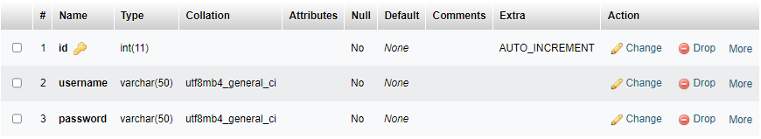

Table 2: Security Defense [dept]
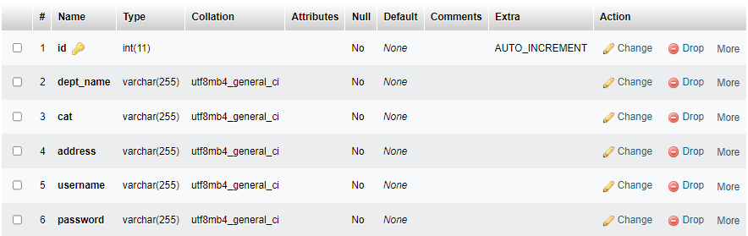

Table 3: Lodged Reports [lodge]
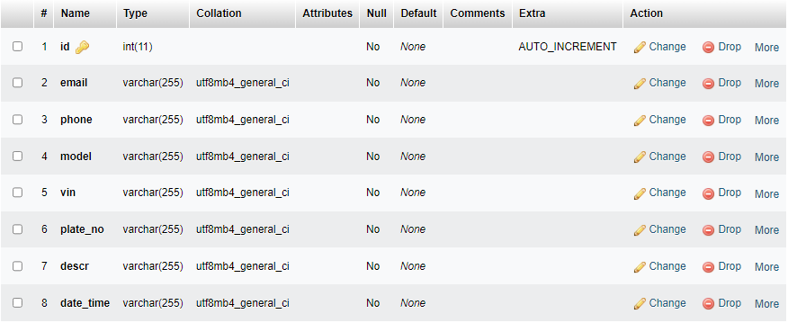

Table4: Rescued Vehicles [rescued]

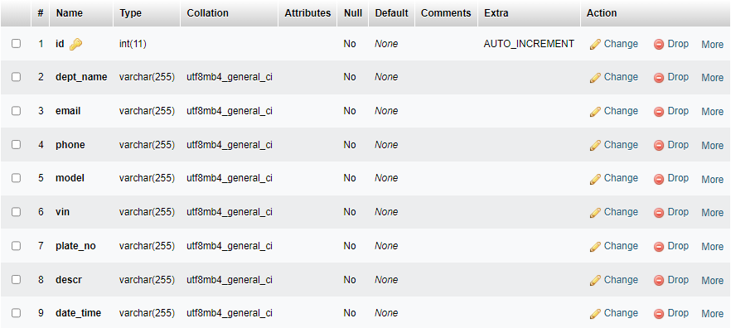

CHAPTER FOUR

SYSTEM IMPLEMENTATION TESTING

4.1 INTRODUCTION
This chapter contained the implementation and testing of online vehicle theft reporting system, the implementation stage confined how the logical design was implemented in to program code. System Testing entails the procedure of implementing a program using a test data with the determination of uncovering and amending errors in the program.

4.1 SYSTEM IMPLEMENTATION
The system was developed as an interactive mechanism between the user interface, and the database using the web browser. It was designed using Visual Studio Code (V.S code) and Xamp server. These tools enable the admin and the user through a browser to interact with MySQL database to enter, edit, view, and retrieve data, as privilege granted. These activities were achieved using: PHP, CSS, Ajax and HTML forms which offer the best layout to enter, change and view from database. This form was also kept as short and simple as possible to suit the individual who will provide data.
The choice of programming used is top-down approach. This approach was used because the project arrangement was in linear format and linear format is always from top to-down to achieve a goal.

4.2 SYSTEM TESTING
To ensure that the system yield the expected result we use black box testing, Black box testing, a form of testing that is performed with no knowledge of a system's internals, can be carried out to evaluate the functionality, security, performance, and other aspects of an application.

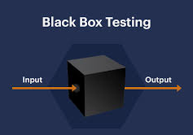

Figure 4.1: Black box testing
METHOD OF BLACK BOX TESTING
The table below tests the proposed system using black box testing in order to prove that the system yield what is expected from it.
1. Admin Dashboard
Input | Expected Output | Actual Output | Condition
Existing username  Correct password | Successful login | User login was successful | 
Existing username  Incorrect password | No login with error message | User can’t login. Error message: Incorrect login credentials | 
Successful login:  System management | Manage activities in the system | Manage security defense, reports, and rescue vehicle

2. User Dashboard
Input | Expected Output | Actual Output | Condition
Existing username  Correct password | Successful login | User login was successful
Existing username  Incorrect password | No login with error message | User can’t login. Error message: Incorrect login credentials
Lodge report:  Successful login | Grant access to lodging page | Lodge report, view rescued vehicles

4.2.1 ADMINISTRATOR DASHBOARD
The administrator dashboard is a desktop software application managing the elections. It incorporates the basic CRUD (Create, Read, Update and Delete) features for monitoring and managing reports, security defence, and rescue vehicles. It accesses the server which for its data that are contained in the database. The administrator dashboard has a login page as shown below to restrict unauthorized access to the dashboard. The login will require username and password for authentication and validates it against the values in the database. If validation succeeds, access to the dashboard is granted, else he/she is restricted. Below are the name of some pages and their functions in the system:
1. Admin Login Page: this is the first step where an admin can input his username and password.
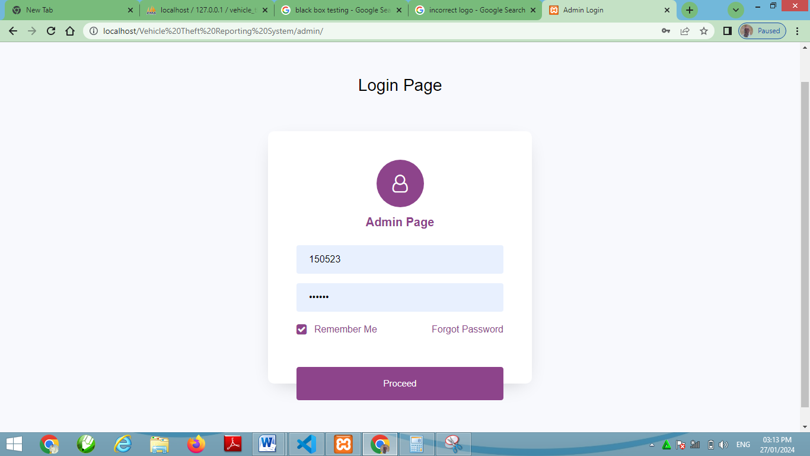Figure 5.1: Admin login page

2. Admin Dashboard: This is where admin can manage reports, rescue vehicle, and manage security defence.
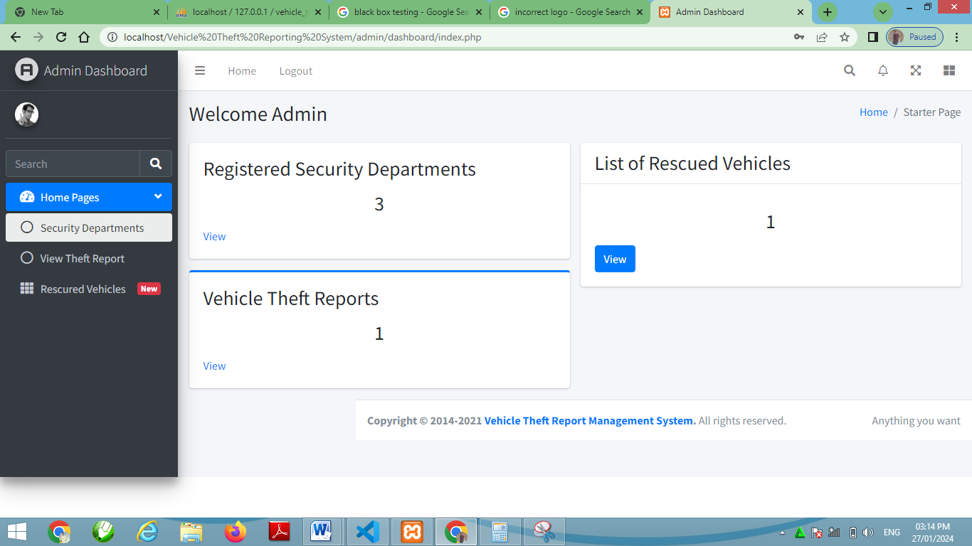

Figure 5.2: Admin dashboard
3. Add Security Department
This is where the admin can add other security department.
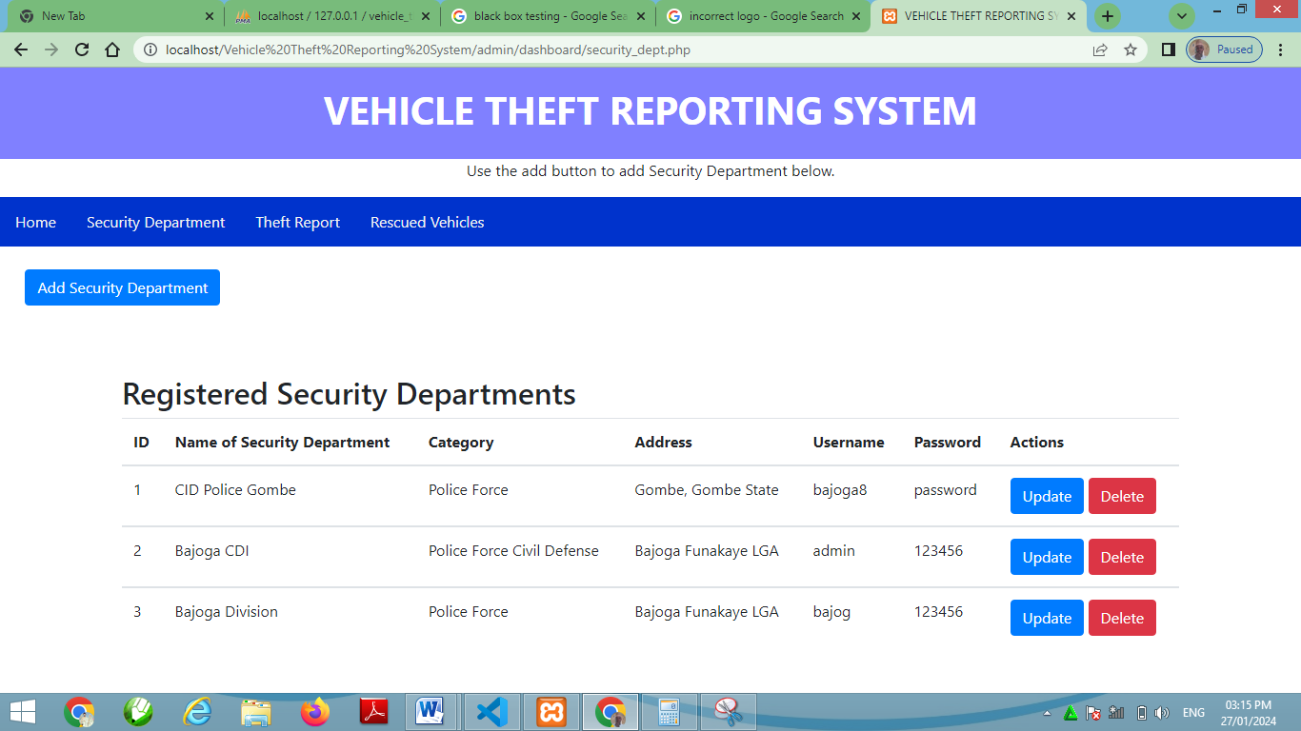Figure 5.3: Security department
4. Theft Report
Is the page that display to admin all vehicle theft reports
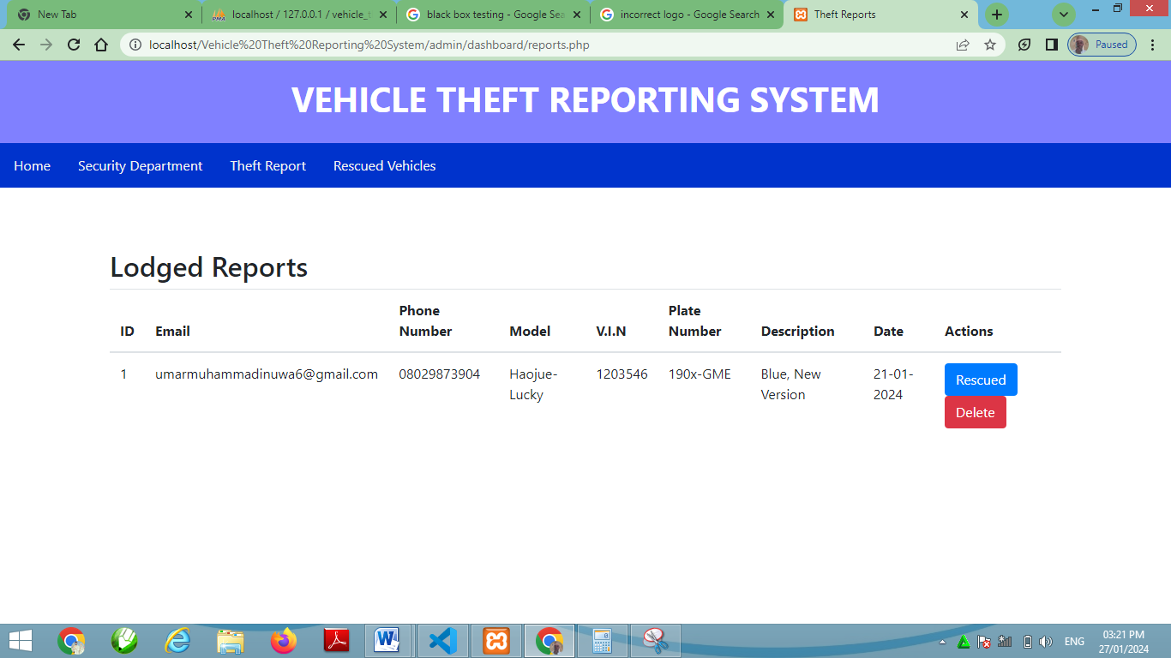

Figure 5.4: Theft report
5. Rescue Vehicle
This is where the admin can recover a rescued vehicle to allow user see his vehicle after being recovered. 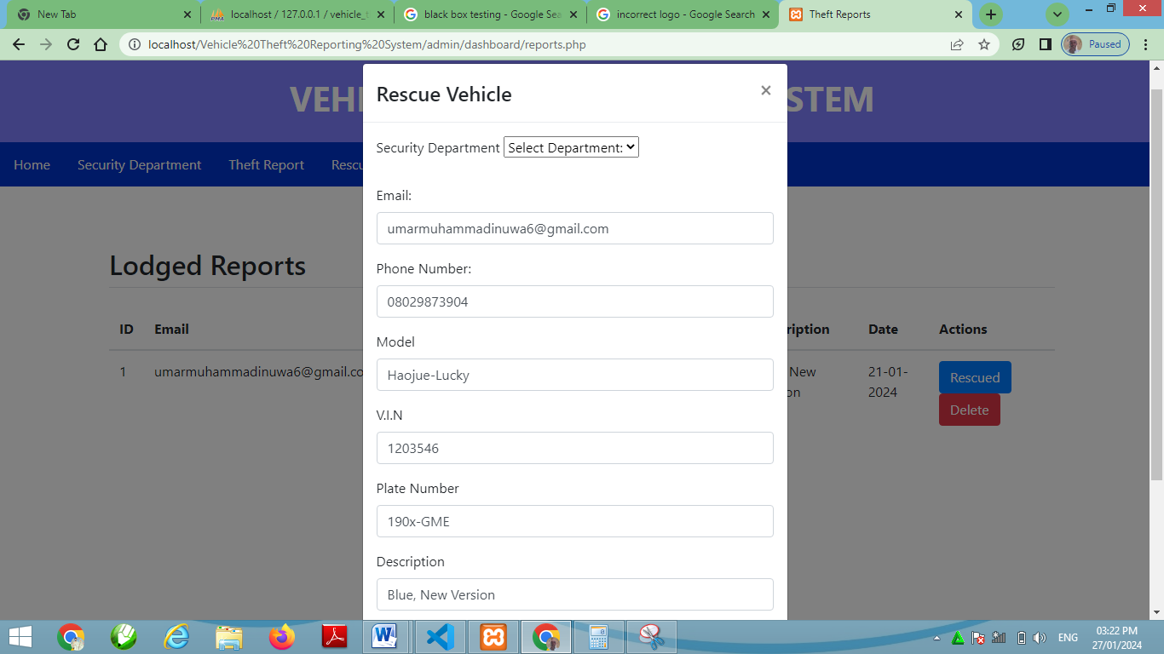Figure 5.5: Rescue vehicle
6. Security Defence Dashboard
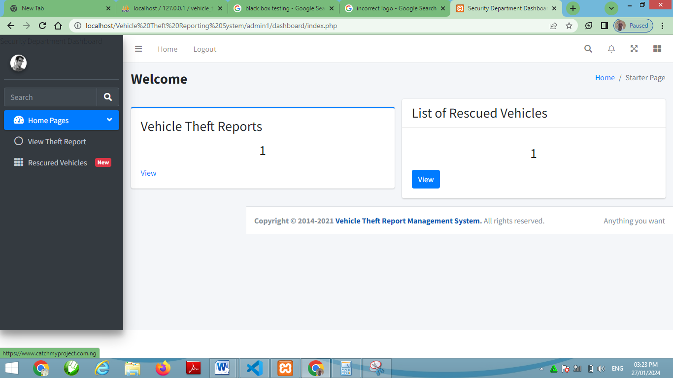

Figure 5.6: security defence dashboard
7. View Theft Report
Is the page that display to security defence all vehicle theft reports

Figure 5.7: View Theft report

8. Rescue Vehicle
This is where the security defence can recover a rescued vehicle to allow user see his vehicle after being recovered.
Figure 5.8: View Rescue vehicle
9. User Page
Is the page for all users to lodge their crime or vehicle theft report so that admin can receive and take all the necessary action.
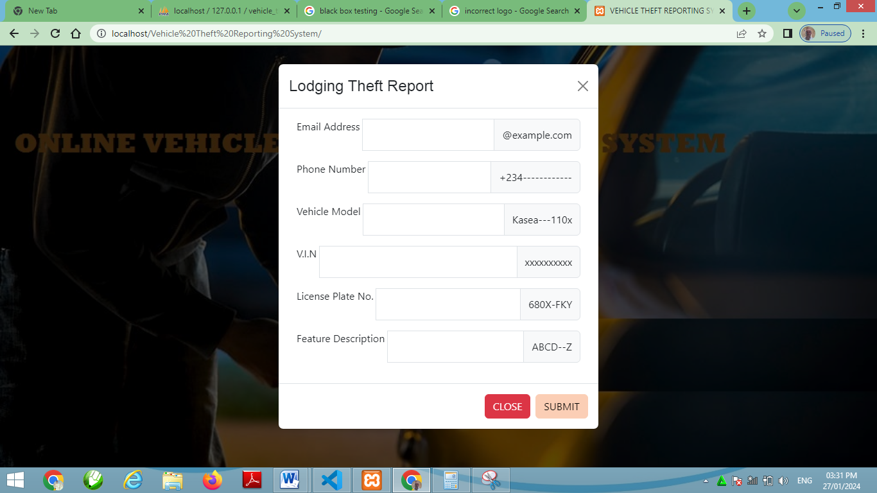

Figure 5.9: User page

CHAPTER FIVE

SUMMARY, CONCLUSION AND RECOMMENDATION

5.1 SUMMARY
The manual system of reporting vehicle theft reporting system in Nigeria has failed to tackle the basic issues necessary for a clean and trusted theft report which result in loss of vehicles in the country. The online vehicle theft reporting system was implemented to solve the proximity bugs, unnecessary time delays, with very secure and accurate lodging reports. The system has been thoroughly tested in reporting and was termed to be with accuracy, ruggedness, responsiveness, battery life expectancy, and security by means of simulation and mini reporting sessions to be a successful one. It is seen that the system is fault tolerant at all end.
The database can store a huge amount of data for later use and further necessary action.

5.2 CONCLUSION
This paper has come as a platform to propose an online vehicle theft reporting system that will place our security defence on a path of success. In a nutshell, this research seeks to increase the efficiency of vehicle theft reporting system process and the image of the. This System is simple and indigenous. It has an authentication feature that will manage the reports other security defence by which voter can login and use their task in the system. There is a database in which all the emails of the reporters with complete information is stored and it provides the tools for maintaining and contacting them. By implementing this system, theft report can easily reach security defence and that all the necessary action can be taken to rescue your vehicle. Also, there should be an expectation of decrease in vehicle theft because all the criminals caught will be punished according to the law of the federation of Nigeria.

5.3. RECOMMENDATION
After completing this research, the following recommendation were made:
1. Vehicle owners should implement the use of vehicle theft detector (a detector that triggers report of theft attack to a vehicle owner’s smart phone.
2. Implementation of Two-factor authentication used to advance security.

REFERENCE
Adegoke, N. (2014). The Nigeria police and the challenges of security in Nigeria. Review of Public Administration and Management, 3(6), 21–35 https://www.ara bianjbmr.com/pdfs/RPAM_VOL_3_6/3.pdf.
Ajayi, J. O., & Longe, O. (2015). Public perception of the police and crime prevention in Nigeria. British Journal of Education, Society and Behavioural Science, 6(2), 148–153. https://doi.org/10.9734/ BJESBS/2015/12763.
Akinlabi, O. M. (2017). Do the police really protect and serve the public? Police deviance and public cynicism towards the law in Nigeria. Criminology and Criminal Justice, 17(2), 158–174. https://doi.org/10.1177/ 1748895816659906.
Ayodele, J. O., & Aderinto, A. A. (2014). Public confidence in the police and crime reporting practices of victims in Lagos Nigeria: A mixed method study. International Journal of Criminal Justice Sciences, 9 (1), 46–63 https://www.sascv.org/ijcjs/pdfs/ Ayodele&Aderintoijcjs2014vol9issue1.pdf.
Boateng, F. D. (2016). Crime reporting behaviour: Do attitudes towards the police matter? Journal of Interpersonal Violence, 33(16), 1–26 doi:10.1177/ 0886260516632356.
Chinwokwu, E. C. (2017). Managing police personnel for effective crime control in Nigeria. Police Science & Management, 19(1), 11–22 https://doi.org/10.1177/ 1461355716677877.
Dempsey, J. S., & Forst, L. S. (2008). An introduction to policing (4th (Thomson Wadsworth) ed.).
Fagin, J. A. (2016). CJ2015. Pearson. Fielding, N. G. (2021). Police communications and social media. European Journal of Criminology, 1–19. https://doi.org/10.1177/1477370821998969.
Kochel, T. R., Parks, R., & Mastrofski, S. D. (2013). Examining police effectiveness as a precursor to legitimacy and cooperation with police. Justice Quarterly, 30(5), 895–925. https://doi.org/10.1080/ 07418825.2011.633544.
Lambert, E. G., Jaing, S., Khondake, M. I., Elechi, O. O., Baker, D. N., & Tucker, K. A. (2010). Policing views from around the globe: An exploratory study of the views of college students from Bangladesh, Canada, Nigeria, and the United States. International Criminal Justice Review, 20(3), 229–247. https://doi.org/10. 1177/1057567710375984.

APPENDIX A
1. LODGING REPORT

2. User Page

APPENDIX B
<?php
include('db.php');

if(isset($_POST['lodge']))
{
$email = $_POST['email'];
$phone = $_POST['phone'];
$model = $_POST['model'];
$vin = $_POST['vin'];
$plate_no = $_POST['plate_no'];
$descr = $_POST['descr'];
$dt = date('d-m-Y');

/*/ first check the database to make sure
// a user does not already exist with the same username and/or email
$user_check_query = "SELECT * FROM patients WHERE patient_id='$patient_id' LIMIT 1";
$result = mysqli_query($connection, $user_check_query);
$user = mysqli_fetch_assoc($result);

if ($user) { // if user exists
if ($user['patient_id'] == $patient_id) {
echo '<script> alert("Patient_ID Already exists");</script>';
header('Reresh: 2; URL= index.php');
}
}
*/

$query = "INSERT INTO lodge (email, phone, model, vin, plate_no, descr, date_time) VALUES
('$email', '$phone', '$model', '$vin', '$plate_no', '$descr', '$dt')";
$query_run= mysqli_query($connection, $query);
if($query_run){
echo '<script>alert("Report Lodged Successfully.");</script> ';
header('Refresh: 2; URL= index.html');
}
else{
echo '<script>alert("Failed, something went wrong.");</script> ';
header('Reresh: 2; URL= index.html');
}

}
?>

